III T E R R A F O R M

- TERRA FORM INTRODUCTION
- Terraform is an open-source Infrastructure as Code (IaC) tool created by HashiCorp
- It lets you define, provision, and manage infrastructure across many cloud providers using a declarative configuration language called HCL ( HashiCorp Configuration Language ).
- Terraform is a tool that lets you write code to describe your infrastructure, and then it automatically creates and manages that infrastructure for you.
- It can work with AWS, Azure, GCP, Kubernetes, VMware, GitHub, Cloudflare, and hundreds more.
- Terraform is a powerful Infrastructure-as-Code tool that lets you manage cloud and on-prem infrastructure using declarative, version-controlled code.
- It improves automation, reduces manual errors, and enables consistent, scalable, multi-cloud environments.
- Automate infrastructure build ( Servers, VM)

Think of it like this: You write a file saying: “I want 1 AWS EC2 instance, 1 VPC, and 1 S3 bucket.”
Terraform reads your file and provisions everything in the correct order.

- Advantages
- It supports multiple providers aws, azure, gcp
- It is idempodent
Idempotent = “Do it once or do it 100 times, the result doesn’t change.”
Present infra will not change as it holds state file
- Can dry run the script : you can plan the execution but it will not deploy
- Split configuration into multiple files
- Manually created resources can import into terraform

- Disadvantages
- You will not get any support from terra form support team until you take license
- If any newly launch feature from any provider and want to use in terraform
You can not use until it tested and verified by terraform.

- Key ideas
      - Infrastructure as Code: You write .tf files describing what your infrastructure should look like.
      - Declarative model: You specify the desired state, and Terraform figures out how to reach it.
you define what infrastructure should exist.
- Provider ecosystem: Works with AWS, Azure, Google Cloud, Kubernetes, VMware, GitHub, and hundreds more.
- Plan & Apply workflow:
  - terraform plan → shows changes before applying
  - terraform apply → provisions/updates infrastructure
- State management: Terraform tracks resource state in a terraform.tf
state file so it knows what exists.
It maintains current resource information in a state file.

- What Terraform can manage
- Servers (EC2, Compute Engine)
- Networks (VPCs, subnets, firewalls)
- Databases (RDS, CloudSQL)
- Kubernetes clusters
- Load balancers, storage, DNS, CDNs
- SaaS configs (Cloudflare, GitHub repos, Datadog monitors, etc.)

- Why people use Terraform
- Repeatable, version-controlled infrastructure
- Cloud-agnostic tooling
- Automated provisioning & deployments
- Safe previews before changes

- Variables & Outputs
      - Variables : Improve reusability:
variable "region" {
default = "us-east-1"
}

      - Outputs : Expose information after provisioning:
output "instance_ip" {
value = aws_instance.web.public_ip
}

- Terraform vs Other IaC Tools
Feature | Terraform | CloudFormation | Ansible | Pulumi
Language | HCL | YAML/JSON | YAML/Modules | Python/TS/Go
Model | Declarative | Declarative | Imperative+Declarative | Declarative (in code)
Multi-cloud | Yes | No | Yes | Yes
State | Yes | Yes | No | Yes
Strength | Multi-cloud, clean syntax | AWS-native | Config mgmt | IaC in real code

- Terraform Is Popular :
- Cloud-agnostic
- Large ecosystem (2000+ providers)
- VCS-friendly IaC
- Readable configuration language
- Predictable, safe changes
- Handles complex dependency logic
- Modular and scalable

- Key Concepts in Terraform
- Infrastructure as Code (IaC) : You store infrastructure in version-controlled code, just like software.
Benefits: Repeatability, No manual clicks, Environment consistency, Easy rollback using Git

- Declarative Language (HCL) : You describe what you want, not how to do it.
Example:
# Create Resource Group
resource "azurerm_resource_group" "rg" {
name = "example-rg"
location = "eastus"}
- Terraform figures out how to create the bucket.

- Providers : Providers let Terraform talk to a service (AWS, Azure, Kubernetes, GitHub, etc.).
Example:
provider "aws" {
region = "us-east-1"
}
- Each provider exposes resources (things you create) and data sources (information you read).

- Resources : These are the building blocks you create—servers, networks, databases, etc.
Example:
resource "aws_instance" "web" {
ami = "ami-123456"
instance_type = "t2.micro"
}

- State File : Terraform keeps a state file ( terraform.tfstate ) that tracks what exists in real infrastructure.
- State allows Terraform to: Know what it already created,
  - Compare desired vs. actual infrastructure
  - Only apply necessary updates

- Execution Plan : When you run: terraform plan
- Terraform shows exactly what it will do: Create, Modify, Destroy
- This prevents accidental changes.

- Apply : When you're ready: terraform apply
- Terraform executes the plan and updates the real infrastructure.

- Modules : Modules let you organize and reuse infrastructure code.
Example structure:
modules/
vpc/
ec2/
rds/
- You can also use Terraform Registry modules (like AWS VPC or Kubernetes cluster modules).

- Why to use Terraform
- Multi-cloud support : One tool to manage AWS + Azure + GCP + Kubernetes + many others.
- Declarative & predictable : You focus on the desired end-state.
- Version control friendly : Infrastructure becomes reproducible.
- Dependency management : Terraform automatically handles order:
VPC → subnets → EC2 instances → security groups
- Modular & reusable : Easy to scale infrastructure architecture.

- Where Terraform Is Used
Use Case | Examples
Cloud provisioning | EC2, S3, VPC (AWS), Azure VMs, GCP Compute
Kubernetes | Deploy clusters, manage namespaces, RBAC
DevOps automation | CI/CD pipelines, GitHub repos
Networking | Cloudflare DNS, load balancers
Hybrid cloud | Datacenter + cloud management
Security | IAM roles, policies, firewalls

- Terraform Workflow or main commands
- Terraform has many Command Line Interface commands,
- But in practice there are about 15–18 core Terraform commands that are commonly used.
- Major Terraform Commands (with Definition & Use)

- Write – create .tf files : for creating new file using .tf extension

- terraform init : Initializes a Terraform working directory.
- Use : Downloads provider plugins, Sets up backend, Must be run first

- terraform validate : Checks whether the Terraform configuration is syntactically correct.
- Use: Finds syntax and logical errors, Does not access cloud resources

- terraform plan : Shows what actions Terraform will take before applying changes.
- Use : Preview changes, Safe review before execution

- terraform apply : Creates or updates infrastructure based on configuration.
- Use : Executes the planned changes, Provisions resources

- terraform destroy : Deletes all resources managed by Terraform.
- Use : Clean up infrastructure, Avoid unnecessary costs

- terraform fmt : Formats Terraform configuration files.
- Use : Makes code readable, Follows standard style

- terraform show : Displays the current state or plan in readable format.
- Use : Inspect resources and values

- terraform state : Used to manage Terraform state file.
- Use : List, move, remove resources from state

- terraform output : Displays output values from Terraform configuration.
- Use : Fetch resource information (IP, DNS, etc.)

- terraform refresh : Updates the state file with real infrastructure data.
- Use : Sync state with actual resources, Mostly replaced by plan and apply

- terraform graph : Creates a visual dependency graph.
- Use : Understand resource relationships

- terraform import : Imports existing resources into Terraform state.
- Use : Manage resources created outside Terraform

- terraform taint : Marks a resource for recreation.
- Use : Force resource replacement, ⚠️ Deprecated in newer versions

- terraform untaint : Removes taint from a resource.
- Use : Cancel forced recreation

- terraform providers : Shows provider requirements and versions.
- Use : Debug provider issues

- terraform workspace : Manages multiple environments.
- Use : Separate dev, test, prod

- terraform login : Authenticates Terraform with Terraform Cloud.
- Use : Access remote state and cloud features

- terraform logout : Removes Terraform Cloud authentication.
- Use : Security and access control

- TERRAFORM VIRTUAL NETWORK PEERING
Recall :
- It supports multiple providers
- It is idempotent ( can run multiple times but code and execution does not change same result depends on code )
- Dry run the script
- Split configuration into multiple files
- Manually created
- Created with .tf extension

Having 2 blocks
- Provider block : provider inf
- Resource block : to create resource

Type of code execution :
- Terraform init : it will download provider related plugins
- Terraform validate : it validate code syntax
- Terraform plan : it will review and shows what it does
- Terraform apply : it will create the resources
- Terraform fmt : it will organized the code
- Terraform destroy : it will destroy all resources

Code Blocks :
Provider block “azurerm” {Authentication }
Resource block resourcetype referencename {}

Def :
- Terraform VNet Peering is a way to connect two or more Virtual Networks (VNets) in Azure so that they can communicate with each other privately, without going through the public internet.
      - Using Terraform, you can declare VNet peering as code, making it repeatable, version-controlled, and automated.

- Why to use VNet Peering?
- Private communication: Traffic between VNets stays within Azure’s backbone network.
- Low latency & high speed: Faster than using VPN or public IPs.
- Flexible architecture: You can connect VNets in the same region or across regions (Global VNet Peering).
- Scalable: Add more VNets without complex networking.

- Terraform and VNet Peering
      - Terraform lets you create and manage VNet peering as code, which means:
        - You can recreate it anytime.
        - You avoid manual setup in the Azure Portal.
        - It’s repeatable and version-controlled.

- Simple Example : Imagine you have VNet1 (10.0.0.0/16) and VNet2 (10.1.0.0/16). You want them to communicate.

# VNet 1
resource "azurerm_virtual_network" "vnet1" {
name = "vnet1"
address_space = ["10.0.0.0/16"]
location = "East US"
resource_group_name = azurerm_resource_group.rg.name
}

# VNet 2
resource "azurerm_virtual_network" "vnet2" {
name = "vnet2"
address_space = ["10.1.0.0/16"]
location = "East US"
resource_group_name = azurerm_resource_group.rg.name
}

# Peering from VNet1 to VNet2
resource "azurerm_virtual_network_peering" "vnet1-to-vnet2" {
name = "vnet1-to-vnet2"
resource_group_name = azurerm_resource_group.rg.name
virtual_network_name = azurerm_virtual_network.vnet1.name
remote_virtual_network_id = azurerm_virtual_network.vnet2.id
allow_virtual_network_access = true
}

# Peering from VNet2 to VNet1 (required)
resource "azurerm_virtual_network_peering" "vnet2-to-vnet1" {
name = "vnet2-to-vnet1"
resource_group_name = azurerm_resource_group.rg.name
virtual_network_name = azurerm_virtual_network.vnet2.name
remote_virtual_network_id = azurerm_virtual_network.vnet1.id
allow_virtual_network_access = true
}

- Key Points:
- Peering is bi-directional: You need two peering resources.
- allow_virtual_network_access = true lets resources talk to each other.
- Terraform automates this process—no manual clicks needed.

- Simple to remember or Analogy
- VNet = Neighborhood
- VM = House
- VNet Peering = Private Road connecting the neighborhoods
- Terraform = Builder who sets up the roads automatically, safely, and consistently

- TERRAFORM VARIABLES

if statefile is in local laptop
1 to add appears
If terraform is in storage or developer laptop then when we run code
It just shows 3 to add as statefile not in local pc
When the same files are already executed it just shows error as already done.

Terraform backend block : will read state file from storage account online from azure
Terraform variable : temporary storage

- Terraform variables are input values that make your Terraform configuration flexible, reusable, and easier to maintain.
      - Instead of hardcoding values in your .tf files, you define variables and assign values separately.
      - This helps you manage configurations for different environments (Dev, Test, Prod) without rewriting code.

- Terraform Variables are important : Using variables provides several benefits:
- Reusability : You can reuse the same Terraform code with different values (region, VM size, resource names, tags, etc.).
- Maintainability : Updating a variable value in one place changes it everywhere it’s used.
- Flexibility : You can provide variable values from:
      - Default values
      - terraform.tfvars files
      - CLI (-var)
      - Environment variables
- Avoid Hardcoding : Hardcoding makes your code rigid. Variables make it dynamic.

- Types of Variables in Terraform : Terraform supports several variable types:
- String : For text values.
variable "location" {
type = string }

- Number : For numeric values.
variable "instance_count" {
type = number }

- Bool : True/false values.
variable "enable_backup" {
type = bool }

- List : For a list of values.
variable "subnets" {
type = list(string) }

- Map : Key-value pairs.
variable "tags" {
type = map(string) }

- Object / Complex Types : Used for structured data.

- Where Do We Define and Use Variables?
- Declare Variable – variables.tf
variable "vm_size" {
type = string
default = "Standard_B1s"
description = "Azure VM size" }

- Use Variable – main.tf
resource "azurerm_linux_virtual_machine" "vm" {
size = var.vm_size }

- Provide Value – terraform.tfvars
vm_size = "Standard_B2s"

- Ways to Assign Variable Values
- Default Value (in variable block) : Automatically used if nothing else is given.
- Terraform Variable File : terraform apply -var-file="dev.tfvars"
- Inline in CLI : terraform apply -var="location=eastus"
- Environment Variables : export TF_VAR_location=eastus
Terraform automatically picks it up.

- Terraform variables are dynamic inputs that help you:
- Avoid hardcoding values
- Manage multiple environments easily
- Make Terraform configurations clean, flexible, and reusable

- TERRAFORM VIRTUAL MACHINE CREATION

- A Terraform virtual machine usually refers to a virtual machine resource created, configured and managed using HashiCorp Terraform.
      - An Infrastructure-as-Code (IaC) tool.
      - Terraform itself is not a virtual machine—it is a tool used to define, provision, and manage infrastructure in cloud or on-prem environments.

- When People Say “Terraform Virtual Machine”
      - A virtual machine created using Terraform configuration files and managed by Terraform commands.
      - They usually mean a VM that is provisioned using Terraform, such as:
  - On AWS → Terraform can create an EC2 instance
  - On Azure → Terraform can create an Azure Virtual Machine
  - On Google Cloud → Terraform can create a Compute Engine VM
  - On VMware vSphere → Terraform can create a vSphere VM
  - On Proxmox → Terraform can create a Proxmox VM
  - On VirtualBox → Terraform can create a local VM
      - Terraform can manage these through providers.
      - VM depends on the provider, but Terraform orchestrates it.

- Organizations Use Terraform to Create VMs
      - Automation & speed : Infrastructure can be deployed without manual clicking in dashboards.
      - Consistency : Every VM uses the same code-defined specs.
      - Scalability : You can scale VMs up/down using code.
      - Version control : Track changes via Git.
      - Infrastructure portability : You can switch cloud providers more easily.

- Characteristics of Terraform-created VMs
- Declarative : You declare what the VM should look like, and Terraform ensures that reality matches the description.
- Immutable infrastructure style : Most changes result in recreation or clean updates.
- Repeatable & automation-friendly : You can recreate the same VM in another region or cloud with minimal changes.
- Version-controlled : Since configurations are text files, they can be stored in Git.
- Multi-cloud by design : The same Terraform workflow can create VMs across different providers.
- Easy teardown (terraform destroy)
- State management so resources aren’t recreated accidentally

- Steps to create Virtual Machine
      - Create RG, Vnet with Subnet
      - Create Public IP address
      - Create Nic card and attach NIC to PIP
      - Create NSG
      - Attach NSG with Subnet
      - Create VM with OS

- TERRAFORM DATATYPES
- A Terraform data type defines the kind of value that can be stored or hold in a variable, local value, or output in Terraform configuration.
- Terraform data types is of 2 categories
    - Primitive data type
    - Complex data type
- Such as string, number, bool, list, map, set, tuple, object and any.

- Primitive (Simple) Data Types : These are basic, single-value types:
- Terraform string: A string in Terraform is a data type used to store text
- Any value written inside quotes (" ")
Ex : name = "my-server"
- "my-server" is a string
- It represents text

- Strings are used for : Resource names, Regions, AMI IDs, File paths, Messages, Tags
      - region = "us-east-1"
      - ami = "ami-0abcdef123"

- Multiline Strings (Heredoc) : Used for long text like scripts or configs.
- Terraform uses HEREDOC (<<EOF ... EOF) to write multi-line strings.
user_data = <<EOF
#!/bin/bash
echo "Hello Terraform"
EOF
- This is still a string, just multiline.

- String Functions : Terraform provides functions to work with strings:
Function | Example | Result
upper() | upper("dev") | DEV
lower() | lower("PROD") | prod
length() | length("hello") | 5
replace() | replace("dev-server","dev","prod") | prod-server
substr() | substr("terraform",0,4) | terr

- A Terraform string is a text value written inside quotes and used to store names, IDs, and other text data.

- Terraform int or number : int is a Terraform data type used to store numeric values without fractions.
- In Terraform, int (short for integer) is a primitive data type used to represent whole numbers

- Code :
variable "instance_count" {
type = number # Terraform uses "number" type for both int and float
default = 3 # This is an integer
}
output "max_retries" {
value = 5 # Integer value
}

- Key Points : Works in variables, outputs, locals, and expressions.
- Terraform doesn’t have a separate int type; it uses number for both integers and decimals.
- Use integers when you need whole numbers (counts, retries, ports, etc.).

- Terraform bool : bool (Boolean) is a primitive data type used to represent a true or false value.
- bool is a Terraform data type used to store a value that can be either true or false.

- Code variable
"enable_monitoring" {
type = bool
default = true # Boolean value
}

output "is_production" {
value = false # Boolean value
}

- Key Points : Only two possible values: true or false.
- Commonly used for:
- Enabling/disabling features
- Conditional logic in Terraform (count, for_each, if expressions)
- Works in variables, outputs, locals, and expressions.

- Complex (Collection) Data Types : These hold multiple values or structured data:
- Terraform list : Ordered collection of values of the same type, accessed by index.
- Terraform, a list is a type of variable that holds multiple values in order.
- Example: ["apple", "banana", "cherry"]

- List Example
variable "fruits" {
type = list(string)
default = ["apple", "banana", "orange"]
}
Here:
fruits is a list of strings.
It has 3 items: "apple", "banana", "orange".
The order matters (first is apple, second is banana, etc.).

- Accessing List Items : You can get a single item by its index (starting from 0):
output "first_fruit" {
value = var.fruits[0] # apple
}

This will create 3 instances, one for each fruit name.

- Key Points: Lists are ordered.
- Index starts at 0.
- Can hold strings, numbers, or other types.
- Use length() to find out how many items.
- Use [index] to access specific items.

- Terraform map : Key-value pairs where keys are strings and all values are of the same type.
- A map is a collection of key-value pairs.
- each key has a value.
  - Key → the name you use to look up the value
  - Value → the data associated with that key
- Example: {"env" = "prod", "region" = "us-east-1"}

- Map example
variable "server_ips" {
type = map(string)
default = {
web = "192.168.1.10"
db = "192.168.1.20"
cache = "192.168.1.30"
}
}

Here: web, db, and cache are keys.
"192.168.1.10", "192.168.1.20", "192.168.1.30" are their values.

- Accessing Map Values : You can get a value by its key:
output "web_server_ip" {
value = var.server_ips["web"] # 192.168.1.10
}

- Using Maps in Resources : Maps are great when you want to assign different values to different resources:
resource "aws_instance" "example" {
for_each = var.server_ips
ami = "ami-123456"
instance_type = "t2.micro"
private_ip = each.value
tags = {
Name = each.key
}
}

This will create 3 instances:
One with IP 192.168.1.10 and Name web
One with IP 192.168.1.20 and Name db
One with IP 192.168.1.30 and Name cache

- Key Points : Maps are unordered (unlike lists).
- Access values by key, not by index.
- Use for_each to create multiple resources dynamically.
- Perfect for associating names with specific values.

- Terraform set : Unordered collection of unique values of the same type.
Example: ["a", "b", "c"] (duplicates not allowed)

- A set is a collection of unique values.
- No duplicates allowed
- Order does not matter (unlike a list)

- Set Example
variable "unique_ports" {
type = set(number)
default = [80, 443, 8080]
}

Here:
unique_ports is a set of numbers
It contains 80, 443, 8080
Terraform will make sure all values are unique

If you try to add duplicates:
default = [80, 443, 80] # 80 will appear only once

- Accessing Set Items : Unlike lists, sets don’t have indexes, so you cannot do var.unique_ports[0].
Sets are usually used with loops or for_each to create resources.

Example:
resource "aws_security_group_rule" "allow_ports" {
for_each = var.unique_ports
type = "ingress"
from_port = each.value
to_port = each.value
protocol = "tcp"
cidr_blocks = ["0.0.0.0/0"]
}

This will create a rule for each port in the set, no matter the order.

- Key Points : Sets contain only unique values
- Order doesn’t matter
- Cannot access items by index
- Good for situations where duplicates are not allowed
- Can be used in loops with for_each

- Terraform tuple : Ordered collection of elements where each element can be a different type.
- A tuple is a fixed-size ordered collection of values, where each value can be a different type.
- A row of mixed items: the first item can be a number, the second a string, the third a boolean—each in a fixed position.
- Example: [ "Alice", 25, true ]

- Code example :
variable "server_info" {
type = tuple([string, number, bool])
default = ["web-server", 8080, true]
}

Here:
"web-server" → string (name)
8080 → number (port)
true → boolean (active status)
Order matters! The first must be a string, second a number, third a boolean.

- Accessing Tuple Items : You can get a value by its index, starting from 0:
output "server_name" {
value = var.server_info[0] # "web-server" }

output "server_port" {
value = var.server_info[1] # 8080 }

output "server_active" {
value = var.server_info[2] # true }

- Key Points : Tuples are ordered.
- Each element can be a different type.
- Fixed length—cannot add extra items later.
- Use index [0], [1], [2] to access values.
- Great when you want heterogeneous values together in a fixed structure.

- Terraform object – Structured collection of named attributes, each with its own type.
- An object is a complex type that contains named attributes, and each attribute has a type.
Think of it like a structured record or a JSON object.
Unlike tuples (which use indexes), objects use names for each field.
Example: { name = "Alice", age = 25, active = true }

Object Example
variable "server" {
type = object({
name = string
port = number
active = bool })

default = {
name = "web-server"
port = 8080
active = true } }

- Here :
name → string
port → number
active → boolean
Each field has a name and a type

- Accessing Object Attributes : You access values by their attribute name:
output "server_name" {
value = var.server.name # "web-server" }

output "server_port" {
value = var.server.port # 8080 }

output "server_active" {
value = var.server.active # true }

- Using Object in Resources :Objects are useful when you want to pass multiple related values into a resource:
resource "aws_instance" "example" {
ami = "ami-123456"
instance_type = "t2.micro"
tags = {
Name = var.server.name
Active = tostring(var.server.active) } }

- Key Points : Objects have named attributes, unlike tuples (index-based).
- Each attribute can have a different type.
- You can access values using dot notation: object.attribute
- Great for passing structured data to modules or resources.

Category | Type | Example
Primitive | string | "dev"
Primitive | number | 1
Primitive | bool | true
Complex | list | ["a", "b"]
Complex | tuple | ["a", 1, true]
Complex | set | toset(["a","b"])
Complex | map | { key = "value" }
Complex | object | { name="x", age=1 }

- TERRAFORM WORKSPACE
- Terraform workspace is a way to manage multiple environments (like dev, test, prod) using the same Terraform configuration, without duplicating code.
- A workspace is basically a separate state file for the same Terraform code.
      - Same code, Different state, Different environment

Think of it like this:
Same Terraform files
│
├── dev workspace → dev.tfstate
├── test workspace → test.tfstate
└── prod workspace → prod.tfstate

- Each workspace keeps track of its own infrastructure.

- Why Do We Need Workspaces?
- Without workspaces:
  - You must copy Terraform files for each environment
  - Hard to manage, Risk of mistakes
- With workspaces:
  - One codebase, Multiple environments, Clean separation of state

- Simple Real-World Example
- Imagine you want: Dev server → small EC2, Prod server → large EC2
- Same Terraform code, different environments.

- How Workspaces Work Internally
- Terraform stores state like this:

terraform.tfstate.d/
├── dev/
│ └── terraform.tfstate
├── prod/
│ └── terraform.tfstate
- Each workspace = isolated state

- Basic Workspace Commands
- Create a workspace : New
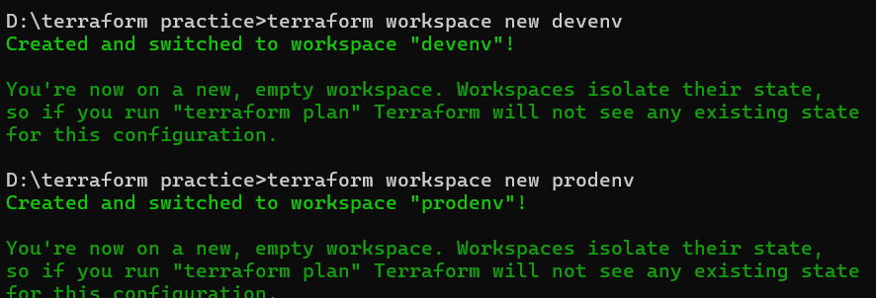

- List : For showing how many terraform workspaces are there

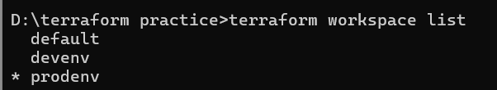

- Show : It shows in which workspace are we currently

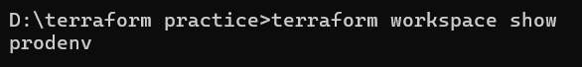

- select : Used to switch from one workspace to another

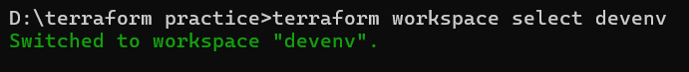

- delete : used to delete work space

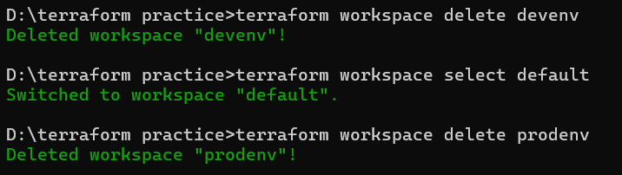

- Using Workspace in Terraform Code
- Terraform provides a built-in variable : terraform.workspace

Example: Different instance sizes per workspace
variable "instance_type" {
type = map(string)
default = {
dev = "t2.micro"
prod = "t2.large"
}
}

resource "aws_instance" "example" {
ami = "ami-123456"
instance_type = var.instance_type[terraform.workspace]
}

- If workspace is dev → t2.micro
- If workspace is prod → t2.large

- Workflow Example
terraform init

terraform workspace new dev
terraform apply # creates dev infrastructure

terraform workspace new prod
terraform apply # creates prod infrastructure

- No conflicts, no overwriting.

- When Should You Use Workspaces?
- ✅ Good for:
- Dev / test / prod in same AWS account
- Small to medium projects
- Learning Terraform

- ❌ Not ideal for:
- Very large environments
- Multiple AWS accounts
- Strict isolation needs

- For large systems, separate backend + separate Terraform projects is better.

- Terraform Workspace vs Separate Folders
Workspaces | Separate Folders
One codebase | Multiple code copies
Easy to manage | More control
Same backend | Separate backends

- Terraform workspace lets you use the same Terraform code to manage multiple environments by keeping separate state files.

- TERRAFORM depends_on
- In Terraform, depends_on is used to force the creation of one resource after another.
- Sometimes Terraform cannot automatically figure out the order in which resources should be created.
- depends_on tells Terraform: “Make sure this resource is created only after these other resources are finished.”

- Simple Code :
resource "azurerm_resource_group" "rg2" {
name = "rg2"
location = "east asia" }

resource "azurerm_resource_group" "rg3" {
name = "rg3"
location = "east asia"
depends_on = [ azurerm_resource_group.rg2 ] }

- It will create as order on depends from top to bottom : As rg 2 -> 3
- Here 1st rg2 will create 1st later rg3

- Key Points : depends_on is optional; Terraform automatically detects most dependencies.
- Use it when dependencies are implicit or Terraform can’t detect them.
- Syntax : depends_on = [resource_type.resource_name, ...]
In short: depends_on tells Terraform: “Don’t create this resource until these ones are ready.” ✅

- TERRAFORM DATA BLOCK AND IMPORT COMMAND
- Resource : to create new resources
- Variable : to declare variable

- Data block is to read the existing information from cloud or online
- Import : to import resources infra from azure online to local state file

We have infra team
Infrastructure team will create : rg vnet and subnets using manual or terraform may be anything
Our work is to create virtual machines in provided infra

- DATA BLOCK IN TERRAFORM
- A data block is used to read or fetch information from existing resources rather than creating new ones.
- Something that already exists, Useful for referencing existing resources in your Terraform configuration.

- While you browse in terraform azure resource block : You can find resource block and data block

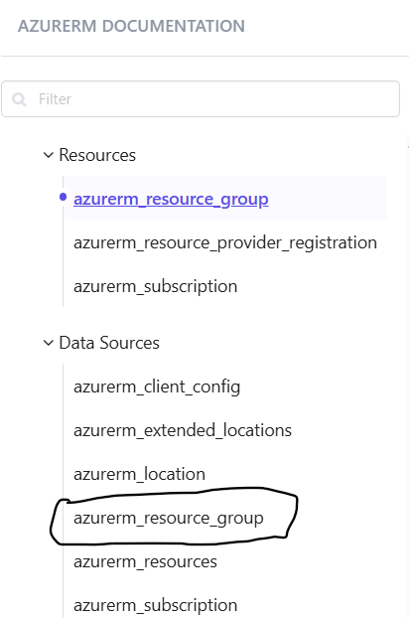

- Code syntax :
data “azurerm_resource_type” “reference_name” {
Name = “existing_name “ }

- This block just shows resource group name reference id from cloud
data "azurerm_resource_group" "ex" {
name = "Saistorage" }

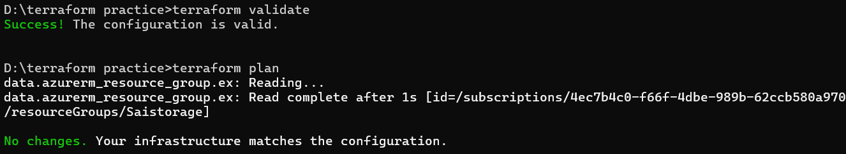

- But if we use output block
- It print the id on the screen

Code : data "azurerm_resource_group" "ex" {
name = "Saistorage" }

output "rg_id" {
value = data.azurerm_resource_group.ex.id }

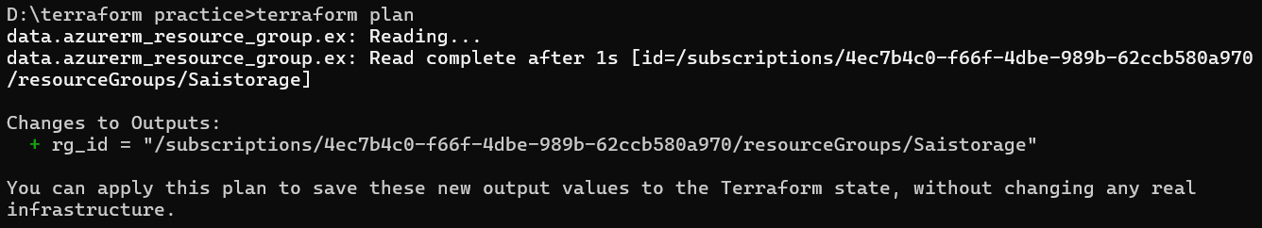

- Terraform does not create a new VPC, it just uses the existing one.

- Now create virtual network using the existing resources using data block
- Let us create virtual network

data "azurerm_resource_group" "ex" {
name = "Saistorage" }

# virtual network block ( while doing put both existing resource block with output and virtual network block
resource "azurerm_virtual_network" "vnet"{
name = "vnet1"
address_space = ["10.4.0.0/16"]
resource_group_name = data.azurerm_resource_group.ex.name
location = data.azurerm_resource_group.ex.location
}

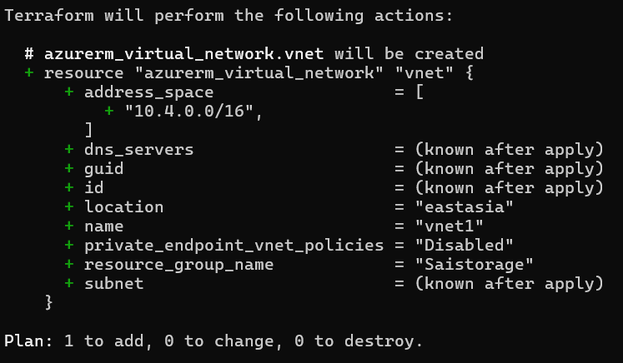

- Now we have created virtual network using existing resource group
- If we want to destroy or delete we can only destroy virtual network but not resource group
- Because virtual network infra code is in local state file but resource infra code is in cloud in some one subscription

- Key Points : Data blocks are for reading existing resources.
- They do not create anything.
- Can fetch resources by ID, tags, or other filters.
- Commonly used for getting values from existing infrastructure.
- Simple : data block = “look up and use existing resources”

- IMPORT BLOCK IN TERRAFORM
- Terraform import is a command used to bring an existing resource into Terraform’s state.
- Sometimes, a resource is already created manually or by another tool.
Terraform doesn’t know about it yet.
Using import, you tell Terraform:
“This resource already exists. Please track it in Terraform.”
- Terraform tracks it and download or imports infra source code from cloud to terraform state
- Import block is used for
- To manage existing infrastructure with Terraform.
- Avoid destroying resources that were created outside Terraform.
- Helps make your Terraform configuration match the real environment.

- While executing :
Terraform import azure_resource_group.rg <rg_id>

- Now resource group state file imported
- Now if you destroy from terraform it would delete resource group and vnet also
- As state file contains both virtual network and resource group

- Key Points : terraform import does not create resources.
- It only updates Terraform state to track existing resources.
- You still need the resource block in your code.
- Useful for bringing legacy infrastructure under Terraform management.

- Simple : Terraform import = “tell Terraform to manage something that already exists” ✅

- TERRAFORM MODULES
- A module is like a container for multiple Terraform resources that are used together.
- It is reusable code which is already available

- For uat : rg, vnet and subnet
- For production : rg, vnet, subnet and vm
- For dev : rg, storage and load balancer

- For this kind of environments we need to create or add blocks and delete based on requirement

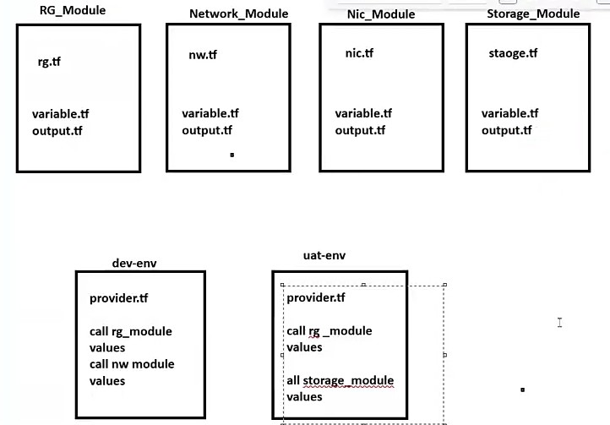

- Here we can have raw code
- No provider, terraform, plugins, variable, values

- When you create environment
  - Based on environments you call module and provide values

Now create a folder in file manager
- Devenv
- Infra
  - Rg
  - vnet

Think of it like a function in programming: you can reuse it with different inputs.
Modules help make your code organized, reusable, and easier to manage.

- Types of Modules
- Root Module – the main Terraform folder you are working in.
- Child Module – a module called by another module.
- Registry Module – pre-built modules you can use from the Terraform Registry.

- Simple Example of a Module

Step 1: Create a module folder
Folder structure:
terraform/
├── main.tf # root module
├── modules/
│ └── dev_env /
│ ├── main.tf
│ ├── variables.tf
│ └── outputs.tf

Step 2: Define a module (modules/dev_env /main.tf)
resource "azurerm_resource_group " "rg1" {
name = var.rg1_name
loc = var.rg1_loc
}

variables.tf:
variable "rg1_name " { }
variable "rg1_loc " { }

outputs.tf:
output "rg1_id" {
value = azurerm_resource_group.rg1.name
value = azurerm_resource_group.rg1.loc }

Step 3: Use the module in root module (main.tf)
module "rg01" {
source = "../rgvnet/rg"
rg_name = "RG01"
rg_loc = "east asia" }

output "azurerm_resource_group_id" {
value = module.rg01.rg_id }

- source tells Terraform where the module is located.
- You pass variables (azurerm_resource_group) to customize the module.
- You can reuse the same module multiple times with different inputs.

- Key Points : Modules group related resources.
- They make code reusable.
- Can have variables and outputs.
- Can be local (in your project) or remote (from Terraform Registry).
- Helps organize large Terraform projects.

- TERRAFORM PROVISIONERS
- A Terraform provisioner is a feature used to execute scripts or actions after a resource is created or destroyed.
- It helps with initial setup or configuration of infrastructure resources.
- Terraform provisioners allow you to run commands or copy files to a resource as part of the Terraform lifecycle.

- Why Provisioners Are Used : Provisioners are typically used to:
- Install software on servers
- Copy configuration files
- Run initialization scripts
- Perform setup tasks that cannot be done through resource arguments

- Important Notes
- Provisioners run after resource creation
- If a provisioner fails, Terraform may mark the resource as tainted
Marked for destruction and recreation. ✅
Or in a single word: “invalid”
- They are not recommended for routine configuration

- Total: 3 Terraform provisioners

- local-exec → runs commands on your local machine (Terraform host).
- Used to copy files or directories from your local machine to a remote resource (like a VM).
- Uploading configuration files or scripts to a server after it’s created.

- Code :
resource "azurerm_resource_group" "example" {
name = "rg-example"
location = "East US" }
resource "null_resource" "example" {
provisioner "local-exec" {
command = "echo Resource Group ${azurerm_resource_group.example.name} created!" } }

This prints the message on your local machine’s terminal, confirming the resource group was created.

Code meaning : Azure Resource Group is created.
Local message is printed via local-exec on your machine.
null_resource itself doesn’t create any Azure resources, it’s only used to attach provisioners.

- remote-exec → runs commands on the Azure VM via SSH or WinRM.
- remote-exec is a Terraform provisioner that runs commands on the VM itself.
- It connects via SSH (Linux) or WinRM (Windows).
- Commonly used to install software, run scripts, or configure the VM after creation.
- Runs a command on the machine where Terraform is executed, not on the resource itself.
- Running a shell script, calling an API, or printing output after resource creation.

resource "azurerm_linux_virtual_machine" "example" {
name = "vm-example"
resource_group_name = azurerm_resource_group.example.name
location = azurerm_resource_group.example.location
size = "Standard_B1s"
admin_username = "azureuser"
admin_ssh_key {
username = "azureuser"
public_key = file("~/.ssh/id_rsa.pub")
}
}

resource "null_resource" "configure_vm" {
depends_on = [azurerm_linux_virtual_machine.example]

provisioner "remote-exec" {
connection {
type = "ssh"
host = azurerm_linux_virtual_machine.example.public_ip_address
user = "azureuser"
private_key = file("~/.ssh/id_rsa")
}
inline = [
"sudo apt-get update",
"sudo apt-get install -y nginx"
]
}
}

- file → copies files from local machine to the Azure VM.
- Runs commands directly on the remote resource (usually via SSH or WinRM).
- Installing software, updating packages, or starting services on a server.
- The file provisioner is used to copy files or directories from your local machine to a remote resource.
- Typically used with Azure VMs to upload scripts, config files, or templates.

- Code
resource "azurerm_linux_virtual_machine" "example" {
name = "vm-example"
resource_group_name = azurerm_resource_group.example.name
location = azurerm_resource_group.example.location
size = "Standard_B1s"
admin_username = "azureuser"

admin_ssh_key {
username = "azureuser"
public_key = file("~/.ssh/id_rsa.pub") } }

resource "null_resource" "copy_file" {
depends_on = [azurerm_linux_virtual_machine.example]

provisioner "file" {
source = "app.conf" # Local file
destination = "/home/azureuser/app.conf" # Path on VM

connection {
type = "ssh"
host = azurerm_linux_virtual_machine.example.public_ip_address
user = "azureuser"
private_key = file("~/.ssh/id_rsa") } } }

- Code explain :
- Terraform creates the Azure Linux VM.
- Terraform waits until the VM is ready.
- file provisioner uses SSH to connect to the VM.
- The local file app.conf is copied to /home/azureuser/app.conf on the VM.

- Key Points
- file provisioner does not execute commands, it only copies files.
- Use depends_on to ensure the VM exists first.
- Works with SSH (Linux) or WinRM (Windows).
- Can copy single files or entire directories.

- Simple : file provisioner = copy files from your local machine to an Azure VM after it’s created.

- Simply
- File provisioner is to copy files from local pc to remote server
- Remote exe is to after creating machine if we want to execute we can use it
- Local exe : used to create a file to store values in local file

- Null resource
- To install separate and different software or application in different vm
- Simply while creating multiple vm and want to install different apps null resource is used
- To connect individually and individual resource
- Need separate block to write null resource
- No need provisioner exe block for it

- Code : to execute code and install app
Resource “null-resource” “nr1” {
Provisioner “remote-exec” {
Inline = [ “ touch test1.out “]

#in which vm or system need to update or install with username ad password
Connection {
Host = “${element(azurerm_linux_virtual_machine.main.*.public_ip_address, 0)} “
User = “vmadmin”
Password = “password@123” }

- A null_resource is a resource that doesn’t create anything in your cloud provider.
- It exists only in Terraform.
- Mainly used to attach provisioners (local-exec, remote-exec, file) or to trigger actions when something changes.

- Key Points
- null_resource does not create any actual resource in Azure, AWS, etc.
- It’s used to run provisioners or handle triggers.
- Can be combined with triggers to react to changes in other resources.

- Simple
null_resource = a placeholder in Terraform to run scripts or trigger actions without creating a real resource.

- Terraform Commands from A to Z
      - Below is a comprehensive list of all Terraform CLI commands, organized alphabetically with their usage descriptions.

A
Command | Description
terraform apply | Executes the actions proposed in a Terraform plan to create, update, or destroy infrastructure.

C
Command | Description
terraform console | Opens an interactive console for evaluating Terraform expressions and testing functions.

D
Command | Description
terraform destroy | Destroys all remote objects managed by a particular Terraform configuration.

E
Command | Description
terraform env | (Deprecated) Used to manage workspaces. Replaced by terraform workspace.

F
Command | Description
terraform fmt | Rewrites Terraform configuration files to a canonical format and style.
terraform force-unlock | Manually unlocks the state for the defined configuration, removing the lock on the state for the current configuration.

G
Command | Description
terraform get | Downloads and installs modules needed for the configuration.
terraform graph | Generates a visual representation (DOT format) of the dependency graph of Terraform resources.

I
Command | Description
terraform import | Imports existing infrastructure resources into your Terraform state, allowing Terraform to manage them going forward.
terraform init | Initializes a working directory containing Terraform configuration files. Downloads providers, modules, and sets up the backend.

L
Command | Description
terraform login | Authenticates with Terraform Cloud or Terraform Enterprise and stores the API token locally.
terraform logout | Removes locally-stored credentials for Terraform Cloud or Enterprise.

M
Command | Description
terraform metadata | Provides metadata-related commands. Subcommand: terraform metadata functions — lists available built-in functions.

O
Command | Description
terraform output | Reads and displays the output values from the Terraform state file. Useful for extracting values for scripts or other tools.

P
Command | Description
terraform plan | Creates an execution plan, showing what actions Terraform will take to change infrastructure to match the configuration.
terraform providers | Shows the providers required for the current configuration.
terraform providers lock | Rewrites the dependency lock file to include hashes for a specified set of platforms.
terraform providers mirror | Downloads the providers and saves them to a local directory for use in air-gapped environments.
terraform providers schema | Prints the schemas of the providers used in the configuration in JSON format.

R
Command | Description
terraform refresh | Updates the Terraform state file to match the real-world infrastructure (reads current settings and updates state). (Deprecated in favor of terraform apply -refresh-only)

S
Command | Description
terraform show | Provides human-readable output from a state file or plan file. Can also output in JSON format.
terraform state | Advanced state management command with multiple subcommands (see below).
terraform state list | Lists all resources tracked in the Terraform state.
terraform state mv | Moves an item in the state, used for renaming resources or moving them between modules.
terraform state pull | Manually downloads and outputs the remote state to stdout.
terraform state push | Manually uploads a local state file to the remote state.
terraform state replace-provider | Replaces the provider for resources in the state file.
terraform state rm | Removes specific resources from the Terraform state (without destroying the actual resource).
terraform state show | Shows the attributes of a single resource in the Terraform state.

T
Command | Description
terraform taint | (Deprecated) Marks a resource instance as tainted, forcing it to be destroyed and recreated on the next apply. Replaced by terraform apply -replace.
terraform test | Executes integration tests defined in .tftest.hcl files to validate your Terraform configuration.

U
Command | Description
terraform untaint | Removes the tainted state from a resource instance, preventing it from being destroyed and recreated on the next apply.

V
Command | Description
terraform validate | Validates the configuration files in a directory, checking for syntax errors, internal consistency, and correctness without accessing remote services.
terraform version | Displays the current version of Terraform and all installed providers.

W
Command | Description
terraform workspace | Manages workspaces (isolated state environments).
terraform workspace new | Creates a new workspace.
terraform workspace list | Lists all existing workspaces.
terraform workspace select | Switches to another existing workspace.
terraform workspace show | Shows the name of the current workspace.
terraform workspace delete | Deletes an existing workspace (must not be the currently selected one and must have an empty state).

- Common Flags (Applicable to Multiple Commands)
Flag | Description
-auto-approve | Skips interactive approval of the plan (used with apply and destroy).
-var 'key=value' | Sets a variable value directly on the command line.
-var-file=filename | Specifies a variable definitions file.
-target=resource | Targets a specific resource for the operation.
-state=path | Specifies the path to the state file.
-lock=true/false | Enables/disables state locking during operations.
-lock-timeout=duration | Duration to retry a state lock.
-input=true/false | Enables/disables interactive input prompts.
-no-color | Disables color output in the terminal.
-json | Outputs results in JSON format.
-parallelism=n | Limits the number of concurrent operations (default: 10).
-refresh=true/false | Enables/disables refreshing state before a plan/apply.
-replace=resource | Forces replacement of a particular resource instance.
-compact-warnings | Shows warnings in a more compact form.
-backend-config=path | Provides backend configuration during init.
-reconfigure | Reconfigures the backend, ignoring any saved configuration.
-migrate-state | Migrates state between backends during init.
-upgrade | Upgrades provider and module versions during init.
-out=path | Saves the plan to a file for later execution.
-destroy | Creates a plan to destroy all resources (used with plan).
-recursive | Formats files in subdirectories as well (used with fmt).
-check | Checks if files are formatted without making changes (used with fmt).
-diff | Displays diffs of formatting changes (used with fmt).

- Quick Reference Summary
text

terraform init → Initialize working directory
terraform validate → Validate configuration
terraform fmt → Format configuration files
terraform plan → Preview changes
terraform apply → Apply changes
terraform destroy → Destroy infrastructure
terraform output → View outputs
terraform show → Inspect state/plan
terraform state → State management
terraform import → Import existing resources
terraform workspace → Manage workspaces
terraform console → Interactive expression console
terraform graph → Generate dependency graph
terraform taint → Mark resource for recreation (deprecated)
terraform untaint → Unmark tainted resource
terraform refresh → Refresh state (deprecated)
terraform providers → Show required providers
terraform login → Authenticate to TF Cloud
terraform logout → Remove stored credentials
terraform get → Download modules
terraform force-unlock → Release state lock
terraform version → Show version info
terraform test → Run tests
terraform metadata → Metadata commands

